low income taxpayer clinics - Litc
Application Architecture Description Document

Purpose of document:

This document describes a project’s software system specifically for internal review (UI/UX, operations, and the cyber-security team). There are two phases to this document (see below). The project Developer and Architect should be the main contributors, although the entire team may need to collaborate to complete.

Phase 1 is completing the foundational information internal stakeholders should be presented with and aware of before the team starts development. Phase 1 information should be reviewed prior to beginning development.

Phase 2 is completing this document with all developed architecture functionality. It should capture the general information of the project architecture for the support team to be able to review.



LITC – Low Income Taxpayer Clinics

The LITC CRM software is designed to streamline the grant management process for both Low Income Taxpayer Clinic (LITC) recipients and the internal IRS treasury team responsible for reviewing and processing applications. This software efficiently manages the entire intake application lifecycle of potential award recipients. By leveraging the Salesforce platform, the LITC CRM enables the IRS team to effectively track applications and related forms, ensuring a smooth and organized process from start to finish. Additionally, the system enhances communication and follow-up with applicants, providing a centralized platform for all grant-related activities. The anticipated deployment ultimately improves the efficiency and effectiveness of the grant awarding process, benefiting both the LITCs and the IRS employees supporting them.

Architecture Summary – High Level

Business/Product Owner | Tamara Borland
Digital Services PM and Project PM | Emily Ritter
Architect, Developer(s) and Admin(s) | Kenny Gu, Caroline Pridgen, and Engouday Makonnen
Business Analyst(s) and Quality Analyst(s) | Nick Sperry, Juan Taylor
Integrations with External Systems | SAM.gov
Variations from Existing Enterprise Application Treasury Patterns | None
Software Scope | The application is a newly developed, Salesforce solution designed to manage the grant process for potential recipients. This application will oversee the entire grant lifecycle, from the intake and processing of applications to the issuing of awards, and compliance monitoring by the internal IRS team.
Salesforce Org | Apps-treas2
MVP | - Application Package: Standard Form-424 (Standard Grant Application), Form 13424 (LITC Application), Form 13424-M (LITC Application Narrative), Form 13424-J (Detailed Budget & Budget Narrative)  - Customer Onboarding  - UEI Validation via SAM.gov  - LITC Portal  - Roles  - Reports / Dashboards  - Email Notifications  - Communication between Applicant and IRS Users (email-to-case)  - Treasury IRS Application Review Process  - Intake Review  - Technical Review  - Staff Review  - NTA Report  - Compliance Checks  - Compliance Reporting  - Closeout
Security Considerations | SAM.gov – Storing PII information for Applicants
External Users (Outside Treasury) | Integration with external systems, SAM.gov; ID.me/Login.gov required;
Personas | Internal: Treasury IRS employees  - LITC Program Members  - Ranking Panel Members  External: Non-Treasury groups / individuals who are applying to, recipients of, or otherwise served by the LITC program.  - Law Offices  - Non-Profits (Universities)  - English as a Second Language (ESL) Education Office
UI/UX Requirements | LITC Design Style Guide, TAS (Taxpayer Advocate Services) Design Style Guide
Data Migration | The data migration scope for the LITC application includes migrating previously submitted applications, Notice of Awards (NOAs), and reporting.  - Application for Federal Assistance (2023-2025)  - Funding Award (2023-2025)  - Funding Disbursement (2023-2025)  - Reporting (2024)
Portal | The LITC External Recipient Portal was developed to assist current and future IRS LITC grant recipients with applications, notices of awards, and compliance reporting.
Anticipated # of Users | - Internal Salesforce Standard License Users: 40  - External (Portal) Community Login Licenses: 13,500 logins / year
Impact on System(s) | None
Current Design Limitations | None
Current Design Constraints | Scalability: As forms evolve or specific program requirements emerge, additional fields may need to be added. This can impact the system's scalability.  Reusability: Managing data volume could become challenging if other programs begin using the CRM.  Combination of Salesforce Public Sector Solutions (PSS) and Lightning Web Components (LWC): PSS offers out-of-the-box solutions with Salesforce but is limited by the Salesforce Data Model. On the other hand, LWC provides more customization but requires additional maintenance.
Custom URL (if applicable) | https://litcgrants.treasury.gov
Outbound Email Address | _dl_ea_litcgrants@treasury.gov

Architecture Summary – High level Architecture Diagram
The architecture diagram below summarizes different components involved in delivering LITC Grants Management Solution on Salesforce platform leveraging Salesforce PSS. The LITC portal can be accessed by authenticated users.
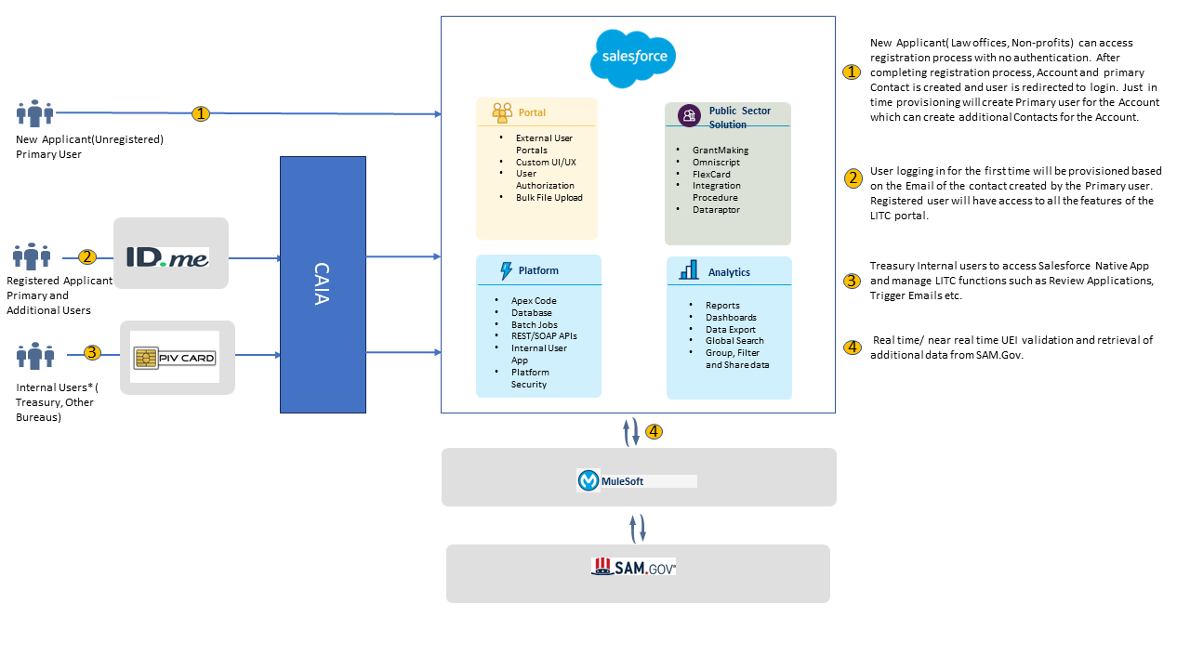

Architecture Summary – Detailed level

Features
- Application Package: Standard Form-424 (Standard Grant Application), Form 13424 (LITC Application), Form 13424-M (LITC Application Narrative), Form 13424-J (Detailed Budget & Budget Narrative)
  - Customer Onboarding
  - UEI Validation via SAM.gov
  - LITC Portal
  - Roles
  - Reports / Dashboards
  - Email Notifications
  - Communication between Applicant and IRS Users
- Treasury IRS Application Review Process
  - Intake Review
  - Technical Review
  - Staff Review
  - NTA Report
  - Compliance Checks
- Funding Decisions
- Notice of Award (NOA)
- Application Amendments
- Interim Compliance Report
- Year-End Compliance Report
- Payments and Reconciliation
- Closeout

Business Process Flows
- User Onboarding Process – [View full-size PDF here]
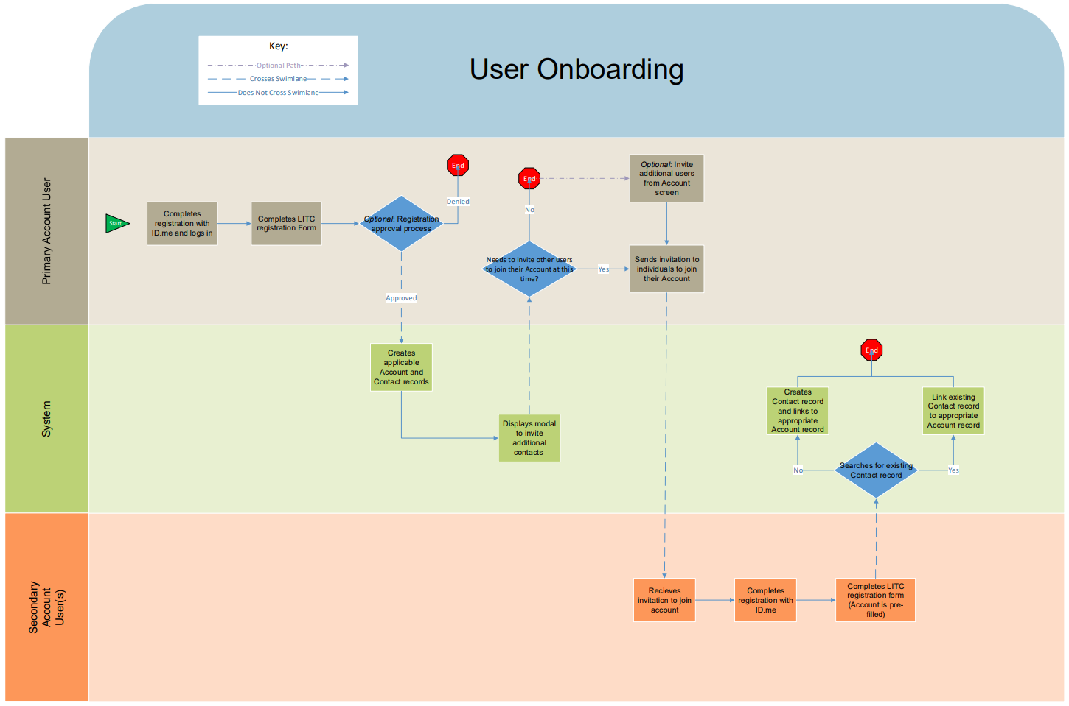
- High-Level Application Process / Record Creation – [View full-size PDF here]

Entity Relationship Diagram (ERD)
This diagram visually represents the Salesforce data model for the solution, detailing the relationships between various objects. This ERD specifies which standard Salesforce objects, out-of-box PSS objects, and custom objects are used to support the required functionality.
[View full-size PDF here]

User Groups and Mapping with Object and Field Level Security: Salesforce Roles, Profiles, and Permission Sets
- Profiles:
  - LITC Customer Community Login
  - LITC Internal User Profile
- Permission Sets:
  - LITC_ IRS_ Internal Administrator (MC)
  - LITC Omni Studio Community Users
  - LITC_Grantmaking for Commnunity Users
  - LITC_ IRS_ Internal User
  - LITC_ IRS_ Ranking Panel User
  - LITC_Community_Users_Permission
  - LITC_ IRS_ Compliance Check
  - LITC Import Wizard Permission

Data Sharing Model Security
Sharing Sets: These will be established based on Standard Objects. For LITC, the Account Object will serve as the main access point for sharing records with Portal-side LITC Grant Recipients.
Sharing Rules: Internal IRS employees and ranking team members will have access to records throughout the internal Salesforce System, with Sharing being open per customer request.

Automations – Triggers, Flows, Workflows
- UEI validation via SAM.gov
  - Direct callout to MuleSoft API. Results are returned and stored in Salesforce.
- Application Submission Logic
  - Upon submission of an application, automation is triggered to perform all validation checks and ensure required fields and dependencies are satisfied before proceeding.
- Review Process Automation
  - When an application is submitted, backend automation creates associated records including: NTA Review, Review cards (and Review Answer), Intake Review, Staff Review, Sam.gov Validation, and Compliance Checks.
- Review Card Automations
  - Level 1 Review cards are generated when NTA Review is in the process of Technical Review.
  - Level 2 Review Card is generated when all Level 1 Review cards are submitted and approved.
  - Level 2 Review answers are prepopulated if all level 1 Review answers on all level 1 review cards scored the same evaluation.
- Staff Review Automations
  - PO (Program Official) and RO (Reviewing Official) records are prepopulated with data from AA (Advocacy Analyst) staff review records.
  - Various fields are populated and rolled up to the NTA record.
- LITC Reporting Form Automations
  - Record creation through screen flow – 3 types of forms created: L form, R Form, SF425 Form.
  - On creation of L form, Line items are cloned from the linked application and linked to the generated L form. This is done through Snapshot records.
  - All rollups and formulas for L form line items are calculated through the same process as the application.
- Funding Award Automations
  - Record creation through screen flow.
  - Various fields are automated and pulled from related application and account on funding award creation.
  - Multiple automations update the related application when Funding award is updated.
  - Funding award totals are calculated and roll up to Funding Opportunity.
  - For subsequent Funding award records, the FAIN will automatically get calculated.
    - Logic based on performance year: if application is year 2 or year 3, trigger will attempt to find and populate FAIN from year 1 Funding award.
- Funding Disbursement Automations
  - Funding Disbursement totals are calculated and roll up to Funding Award.
  - Various fields are automated on funding disbursement creation and on update.
- LITC Payment Automations
  - LITC Payment totals are calculated and roll up to Funding Award.
  - Document number is the unique identifier used to link to Funding awards. Payment’s document number field maps to Funding award’s payment identifier field.
- Closeout Automations
  - Internal checks and automations are performed when budget period closeout process is initiated. This includes checks for Report completion, Review card completion, and population of most recent application and reporting form.
  - Various fields are automated on Funding award and on related application when budget period closeout is finalized.
  - Project period record creation after budget period closeout is finalized, through screen flow.
- Site Visit Automations
  - Record creation through screen flow.
  - Various fields are automated on the Site Visit record from the Account.

Reusable/New LWC and PSS Omni Components
The Salesforce Team utilized a combination of Lightning Web Components (LWC) and PSS Omni Components to meet the IRS requirements for the LITC application. Utilizing Salesforce PSS accelerators gave us a model to incorporate into LWCs following Salesforce’s design. This approach ensured that the application was built using robust, scalable, and flexible components that align with the latest standards and best practices. By integrating LWC and PSS Omni Components, we were able to provide a seamless user experience and meet all functional and technical specifications outlined by the IRS.

Changes to Existing Salesforce Objects

The following is a list of standard objects that were used and/or modified to accommodate the LITC application:
- Account – Salesforce Standard Object
- Contact – Salesforce Standard Object – Record Type: LITC
- Individual Application – Public Sector Solution Standard Object
  - Extending this object by adding custom child objects that are specific to LITC
- Application Review – Public Sector Solution Standard Object
- Funding Award – Public Sector Solution Standard Object
- Funding Opportunity – Public Sector Solution Standard Object
- Funding Disbursement - Public Sector Solution Standard Object
- SF-425 - Public Sector Solution Standard Object
The following is a list of custom objects that were used to accommodate the LITC application:
- Application for Federal Assistance: This will contain the LITC-specific application fields
  - Application for Federal Assistance - Archived Record: We will potentially build this object to archive versions of Application for Federal Assistance records.
- 13424-J Line Items: This will be used to capture the individual line items the user is required to enter as part of their LITC application (specifically related to the 13424-J Form: Detailed Budget)
- Other Staff: Captures additional staffing records the user is required to enter as part of their LITC application, looks up to Application for Federal Assistance
- Legacy 13424 Application: used to capture legacy application data for first year applicants, looks up to Application for Federal Assistance
- NTA Review: Holds all of review related information across Intake Review (Application Review) , Technical Review (Review Cards), and Staff reviews
- Sam Gov Validation: stores validated recipient Sam.gov information, looks up to Application for Federal Assistance
- Staff Review: Stores different staff review related information
  - Record Types: Advocacy Analyst Review, Business Analyst Review, Program Officer Review, Reviewing Official Review
- Compliance check: Captures compliance related information on the clinic level
- Review Template:
  - Review templates are reusable across multiple programs
  - manually created initially to contain multiple review questions
- Review Question
  - Represents an individual evaluation question.
  - Master Detail to Review Template
- Review Card
  - Record Types: Level 1, Level 2
  - Represents an individual review card that contains multiple review questions for the reviewer to score
  - Looks up to Review Template
  - Each Review card is linked to a panel member
  - rollup scores calculated from associated Review Answers.
- Review Answer
  - Object that Stores the evaluation data for each review question
  - Master Detail to Review card, Lookups to the original Review Question.
  - Created for each Review Question when a Review Card is generated
- LITC Reporting Form
  - Record Types: LITC L Reporting Form, LITC R Reporting Form
  - Represents the LITC Reporting form that contains LITC-specific report fields
- LITC Payment
  - Object that represents individual payments
  - Records are created through data load
  - Payment Identifier is the unique identifier used to link to existing Funding awards
  - Master Detail to Funding Award
- Site Visit
  - This will contain the LITC-specific site visit fields
  - Looks up to account
- Site Visit Eligibility Requirement
  - Used to capture individual line items the user is required to enter as part of their Site Visit
  - Master detail to Site visit

Batch Jobs
Currently, there are no batch jobs identified for the LITC project.

Manual Processes – Anonymous Scripts, Data Loader Updates
IRS staff will need to load payment data from their PMS system to reconcile with Funding Disbursement records. The IRS staff will complete this on an ad-hoc basis.

Emails to be Generated for the External Users
Communication between the application and the IRS will be conducted through standard email as well as automated correspondence from Salesforce. This dual approach ensures efficient and timely communication, allowing for quick updates and information exchange. The automated system will streamline routine notifications and alerts, reducing the chance of errors and ensuring that all parties stay informed throughout the process. By leveraging both standard email and automated Salesforce correspondence, we aim to maintain clear, consistent, and reliable communication with the IRS.
Portal Contacts
LITC Contact Invitation to Access LITC Grant
- Triggering Object: Contact
- Flow: LITC Contact Invitation to Access LITC Grant
- Criteria: A new contact is created with an LITC Role v2 OR Onboarding Expiration Date is updated
- Recipient(s): Contact
- Sender: LITCGrants@treasury.gov
- Subject: Invitation to Access LITC Grants Salesforce Portal
- Email Template: LITC Grants Salesforce Portal Access
Application
Application for Federal Assistance - Submission Email
- Triggering Object: Application for Federal Assistance
- Flow: Application for Federal Assistance – Submission Email
- Criteria: Application Status is updated to Submitted
- Recipient(s): Contacts related to the Related Business Account of the Application with LITC Role v2 of Authorized Official, Financial Staff, or Program Staff
- Sender: LITCGrants@treasury.gov
- Subject: LITC Grants Portal Submission Confirmation
Funding
Funding Disbursement – Issued
- Triggering Object: Funding Disbursement
- Flow: Funding Disbursement – Review Status Update
- Criteria: Review Status of Funding Disbursement is changed from ‘Grants Management Review’ to ‘Issued’
- Recipient(s): Contacts related to the Related Business Account of the Application of the Funding Disbursement with LITC Role v2 of Authorized Official
- Sender: LITCGrants@treasury.gov
- Subject: LITC Notice of Award has been Issued
Funding Decision Completed
- Triggering Object: NTA Review
- Flow: NTA Review _LITC Funding Decision Email_ Finalization
- Criteria: NTA Review’s Review Status is updated to NTA Finalized
- Recipient(s): Contacts related to the Related Business Account of the Application of the NTA Review with LITC Role v2 of Authorized Official, Contacts related to the Sponsoring Organization with LITC Role v2 of Authorized Official
- Sender: LITCGrants@treasury.gov
- Subject: Action Required LITC Funding
Reporting
SF-425 Reporting Reminder Notification
- Trigger Object: SF425 Form
- Flow: SF425 Form_Reminder Notification
- Criteria: Send SF425 Reminder field is checked – This happens automatically 7 days before the Submission Deadline if the record is still Incomplete
- Recipient(s): Application for Federal Assistance’s Clinic Director Email and QBA Email
- Sender: LITCGrants@treasury.gov
- Subject: Reminder LITC [Record Name] Report Due Date Approaching
SF-425 Reporting Accepted/Returned/Submitted
- Trigger Object: SF425 Form
- Flow: SF425 Form_Status Update – Accepted Returned Submitted
- Criteria: Review Status is changed to Accepted/Review Status is changed to Returned/Status is Changed to Submitted
- Recipient(s): Application for Federal Assistance’s Clinic Director Email and QBA Email
- Sender: LITCGrants@treasury.gov
SF-425 Reporting - Report Ready
- Trigger Object: SF425 Form
- Flow: SF425 Form_ Report Ready Notification in Creation
- Criteria: An SF425 Form is created
- Recipient(s): Application for Federal Assistance’s Clinic Director Email and QBA Email
- Sender: LITCGrants@treasury.gov
- Subject: SF-425 Form [Record Name]_Reporting Records Available for Review and Submission
L/R Reporting - Report Ready
- Trigger Object: LITC Reporting Form
- Flow: LITC Reporting Form_Report Ready Notification on Creation
- Criteria: An LITC Reporting Form is created
- Recipient(s): Application for Federal Assistance’s Clinic Director Email and QBA Email
- Sender: LITCGrants@treasury.gov
- Subject: LITC 13424-[L/R] Form [Record Name]_Reporting Records Available for Review and Submission
L/R Returned/Submitted/Accepted
- Trigger Object: LITC Reporting Form
- Flow: LITC Reporting Form _Status Update
- Criteria: Review Status is changed to Accepted/Review Status is changed to Returned/Status is Changed to Submitted
- Recipient(s): Application for Federal Assistance’s Clinic Director Email and QBA Email
- Sender: LITCGrants@treasury.gov
L/R Reporting Reminder Notification
- Trigger Object: LITC Reporting Form
- Flow: L Reporting -Reminder Notification
- Criteria: Send Reminder field is checked – This happens automatically 7 days before the Submission Deadline if the record is still Incomplete
- Recipient(s): Application for Federal Assistance’s Clinic Director Email and QBA Email
- Sender: LITCGrants@treasury.gov
- Subject: Reminder : LITC 13424-[L/R] [Record Name] Report Due Date Approaching
Closeout
Project Period Closeout Completed
- Trigger Object: Project Period Closeout
- Flow: LITC Project Period Closeout Completed
- Criteria: Project Period Closeout Status is changed to Project Period Closeout Completed
- Recipient(s): Contacts related to the Related Business Account of the Application of the Project Period Closeout with LITC Role v2 of Authorized Official
- Sender: LITCGrants@treasury.gov
- Email Template: Project Period Closeout Completed

Integration with Details such as Rest VS SOAP, Authentication Direct VS MuleSoft, Daily Volume etc.
- SAM.gov: The LITC application will utilize the SAM.gov integration via MuleSoft to verify the Unique Entity Identifier (UEI) as part of the LITC recipient’s application process. This integration will ensure that the recipient data is accurate and will confirm that individuals submitting the application are legitimate. By leveraging this integration, we aim to streamline the verification process and enhance the overall security and integrity of the application system.

Data Migration Approach Details
The data migration scope for the LITC application included migrating previously submitted applications, Notice of Awards (NOAs), and reporting.
- Application for Federal Assistance (2023-2025)
- Funding Award (2023-2025)
- Funding Disbursement (2023-2025)
- Reporting (2024)

Version Control
Version | Name of Editor(s) | Date
Version 0.1 | Jeremy Anderson | 10/28/2024
Version 1.0 | Jeremy Anderson | 11/14/2024
Version 2.0 | Kenny Gu, Emily Ritter, Nick Sperry, Caroline Pridgen, Dee Makonnen, Juan Taylor. | 09/26/2025

